S.O.S. MATHEMATICS

Students Review Mathematical Concepts on the Internet

M.A. Khamsi, H. Knaust and N. Marcus
Department of Mathematical Sciences
The University of Texas at El Paso
El Paso, TX 79968
mohamed@math.utep.edu, helmut@math.utep.edu, nancy@math.utep.edu

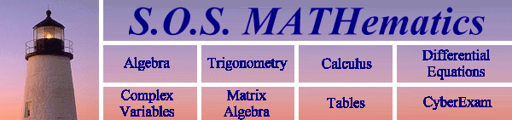

Introduction
S.O.S. Mathematics (URL: http://www.math.utep.edu/sosmath) is an Internet site on the World Wide Web, developed by faculty and students in the UTEP Department of Mathematical Sciences, where students can find material to review mathematical concepts taught both in high school and college. The informal style in which we deliver mathematical help and the easy access are the main reasons for our website’s popularity among students, adult learners, parents and educators. Currently, about 28,000 Internet users visit S.O.S. Mathematics per month.
Our project has been supported since its inception by the National Science Foundation (through UTEP’s Model Institution for Excellence grant), as well as the College of Science and the Department of Mathematical Sciences at our university.

Description
S.O.S. Mathematics is a website featuring review material in Algebra, Trigonometry, and Calculus, as well as more advanced topics such as Matrix Algebra and Differential Equations. Our material is not meant to be a cornucopia of complete web-delivered Mathematics courses. Instead, we aim our site at students who want to refresh their memory of mathematical topics they have learnt in the past, or who want to supplement the material in a mathematics course they are currently taking. Consequently, most of our webpages contain short explanations of a mathematical concept followed by examples of typical problems with their solutions. At the end of a webpage the students usually find exercises to check their understanding of the material.
We are quite surprised at the diversity of our users. Besides our target population of lower-division college students, our site has attracted adult learners who are studying for professional examinations as well as hobby-mathematicians. Many parents seek help on our web site to assist their children with their homework chores.
I think that it is wonderful that you have such a wonderful web site. My algebra teacher introduced your site to us. THANX AGAIN!!! KT

In addition, the site is used heavily by the authors and other interested faculty in our department, both for students’ review of prerequisite material and for in-class presentations by faculty.

In response to requests by many users and in addition to our original plans, we have enlarged the scope of our website to include “Cyberexams”, a practice test site for our users, and some web pages containing mathematical tables and common formulas.

The Start of Our Project
The idea for S.O.S. Mathematics was born in the summer of 1996. Year after year we had complained to each other that our students had forgotten some of the prerequisites for the Mathematics courses we were teaching. Teaching at a university in the fourth poorest congressional district, we were well aware that our students had sold their old textbook immediately after the end of the previous semester, so now they were “stuck” and did not have easy access to the material we assumed as a prerequisite. With computer laboratories spreading throughout our campus, we thought that the Internet presented a solution to this dilemma.
You made a Saturday math assignment for a seventh grader doing fractions very clear. My dad and I were stumped. We just typed in "Dividing Fractions" and there was your page.
Regards, S. C.
The NSF-funded Model of Excellence Initiative at UTEP enabled us to turn our ideas into reality.

Design of the Website
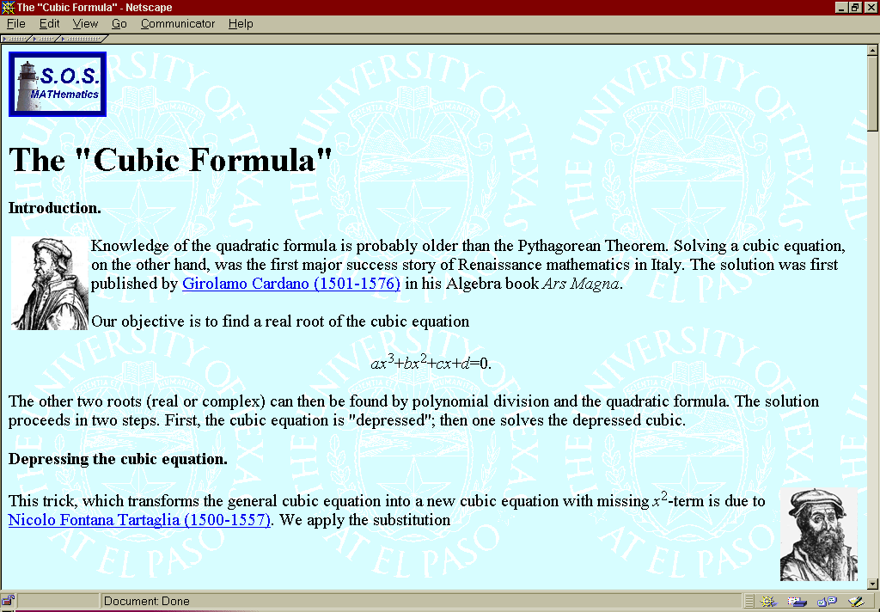
Our choice of technology and presentation was driven by the following concerns: (1) We assumed that our students would access our site either at the university (variety of platforms, no customizability) or at home (old machines, slow Internet connection). Therefore, we decided not to use frames and not to require plug-ins or Java-capability. (2) We wanted to write a lot of material; thus we chose a technology, which was “easy” on authors; most of us were familiar with LaTeX. Consequently, we decided to produce our pages via the LaTeX2HTML route. (3) The Internet makes it easy to accompany text by graphics, so our pages contain a good amount of pictures (produced by Mathematica), and also quite a few GIF animations. (4) Because of the size of the project, we felt we had to pay particular attention to easy navigation through the site. Indeed, it is quite easy for our users to jump from one topic to another. (5) Unlike a book, we did not write our first webpages in a “linear” fashion. Instead we picked our first topics among subjects our students had had most trouble with in the past, such as solving inequalities, factoring polynomials, partial fractions, Taylor series. (6) While our department was in the middle of “Calculus” reform, we wanted our material to be “reform”-neutral to help our students bridge the gap between the old and the new material. Consequently, S.O.S. Mathematics includes topics both from the reform viewpoint and from the “traditional syllabus”.

Present and Future of S.O.S. Mathematics
Today, our S.O.S. Mathematics site contains more than 2,300 webpages. S.O.S. Mathematics has become very popular. Indeed, since August 1996, more than 220,000 users have read a total of about 1.5 million of our webpages.
We have received numerous awards including designation as an approved site by the AAAS Science Netlinks. Our algebra site is included in the BBC Education Web Guide. S.O.S. Mathematics is being mirrored by the Maria-Sklodowska-Curie University, Lublin (Poland) and by La Universidad de Cantabria, Santander (Spain). About one sixth of our site has been translated into Spanish.

We feel that our site is only about 60% complete. During our experience in the last two years we have learnt that there is quite a need for mathematical help via the Internet. We therefore plan to extend our site to include more topics from the high school curriculum such as Geometry. We expect the main production phase of the project to be finished by 2001.

The UTEP administration has felt for quite some time that our project has reached a point where it should be able to support itself. Therefore we have started a company: Math Medics, LLC. S.O.S. Mathematics will eventually move to a commercial server. While access to our site in its entirety will remain “free” to all users, revenue from advertisement hosting and the sale of multimedia products will provide the funds necessary to complete and maintain the web site.

Some Remarks about Website Design Issues
Human Resources. Creating a mathematical web site is quite labor intensive. Try to obtain release time, student help, support by your system manager etc. Nevertheless progress will be excruciatingly slow.
Uniform Look. A good website presents visual identification. All pages on your site should share a few common elements, such as a logo, background etc. The second time a user visits your site he/she should recognize your site by its look, not only by its content. Try to devise an easy and consistent navigation scheme to allow the user to effortlessly access the various parts of your site.
Platform Diversity. The same HTML page can look very different on different computer systems or viewed by different browsers. Try to check the design of your pages on as many different configurations as you can.
Bandwidth. Most of us access the Internet via a “fast” LAN at our university. Many of your users, on the other hand, will use an ISP via a “slow” modem. Keep in mind that your visitors will become impatient if the webpage you designed takes more than a few seconds to download.
Relative Links vs. Absolute Links. It is imperative to use only relative links when linking to files within your site. Use absolute links only when linking to outside resources or to other content on your server. Why? If you use absolute links within your site, you will never be able to move your complete site anywhere else.
Feedback. Make it easy for your visitors to send you feedback. Their comments will help you to improve your site and to eliminate “glitches” you are unaware of.

A “user ” session is defined as continuous activity on a single computer not interrupted by more than 30 minutes.
By Nikos Drakos, Computer Based Learning Unit, University of Leeds. Revised and extended by: Marcus Hennecke, Ross Moore, Herb Swan and others.
Copyright: Wolfram Research, Inc.r
Translation by Ángela Núñez Castaín, Ángel García Santiago, Elisa Abad Palazuelos and Francisco del Campo Ruiz. La Universidad de Cantabria, Santander, Spain.
University of Texas System review of copyright release pending.
An excellent source for finding information about how to minimize the size of GIF files (among other topics) is: David Siegel, Creating Killer Web Sites, Haydon 1996.

