Names: ________________________________________________________________

There is a classical set of data∗ on a pair of interacting predator and prey populations: the Canadian lynx and snowshoe hare pelt-trading records of the Hudson Bay Company over almost a century. The following figure (adapted from Odum, Fundamentals of Ecology, Saunders, 1953) shows a plot of that data. It is known that the snowshoe hare is the dominant food source for the Canadian lynx.

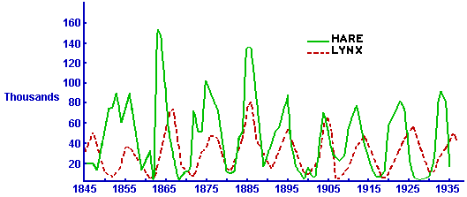

- Do you think that the records of the Hudson Bay Company are representative of the total lynx and hare populations living in the area frequented by trappers working for the Hudson Bay Company? Explain!

- The number of lynx and hare pelts delivered to the Hudson Bay Company fluctuates at more or less regular time intervals. Are these time intervals the same for the lynx and the hare pelts? Give estimates for both of these numbers!

- On average, do the peaks of the lynx population match or slightly precede or slightly lag those of the hare population?

- Do you have any ideas what might have caused the lynx and hare populations to have fluctuated in the manner indicated by the pelts records?

 Source: http://www.math.duke.edu/education/ccp/materials/diffcalc/predprey/pred1.html

